# A Project Report on

**Mood Capture ( An Emotion Detecting App )**

by

**Mr. Rohan Viraj Deshpande**

Introduction

The Application “Mood Capture” has been developed for detecting certain human emotions like anger, contempt, disgust, fear, happiness, neutral, sadness, and surprise by accepting an image as an input and analyzing the image and then providing the emotion detected in that image.

The image can either be clicked at runtime or it can be selected from the underlying drive.

Scope of Work

The “Mood Capture “Application takes an image as an input, and returns the confidence across a set of emotions for the face in the image, as well as bounding box for the face. The emotions detected are happiness, sadness, surprise, anger, fear, contempt, disgust or neutral. These emotions are communicated cross-culturally and universally via the same basic facial expressions, where are identified by Emotion API.

Feasibility Study

In this document we will talk about the feasibility part of creating the **“Mood Capture”** Application.This application has been created based on the Universal Windows Platform or UWP which allows the developer develop apps with just one API set, one app package, and one store to reach all Windows 10 devices – PC, tablet, phone, Xbox, HoloLens, Surface Hub and more.

The Feasibility parameters are as follows:

**Technical Feasibility Study:**

H/W used in this project is Pentium Core i5 4th Generation Processor, 16GB RAM, 200MB HDD Space on existing Computer System, created with the help of Visual Studio 2015.

**Technical Requirement of the System:**

* Platform: Universal Windows Platform
* Device Family: Any devices running on Windows 10
* License: Will need upon production release.

**Economical Feasibility Study:**

* The proposed System is economically feasible because the same API as well as application can be run on any Windows 10 Device like PC, tablet, phone, Xbox, HoloLens, Surface Hub etc. thus reducing Hardware costs.

**Operational Feasibility Study:**

* + This application can be extremely useful to help people understand different emotions especially for blind people or for people with Alexithymia (Alexthymics have difficulty in identifying and describing their own emotions as well as detecting emotions in others ) or small children who cannot comprehend emotions .

Need for System

This application can be helpful to anyone who has an issue comprehending certain emotions be it due to any no. of reasons, race, creed, comprehension or any other physiological or psychological reasons.

Operating Environment:

Hardware & Software

**Hardware:**

* Processor: Core i3 & Above
* RAM: 4GB & Above
* HDD Space: 1GB or Above

**Software:**

* Platform: Universal Windows Platform ( UWP )
* OS: Windows 10 & Above
* IDE’s (Integrated Development Environment): Visual Studio 2015
* Licence: Will be necessary for production use.

Proposed System

**Objectives to be fulfilled:** To assist people who want to know about the Emotions the person in front of them are feeling

**User Requirements:** An application which will detect emotion and will be able to run on any device belonging to the Windows 10 Device Family.

Screen Design

**Main Screen:**

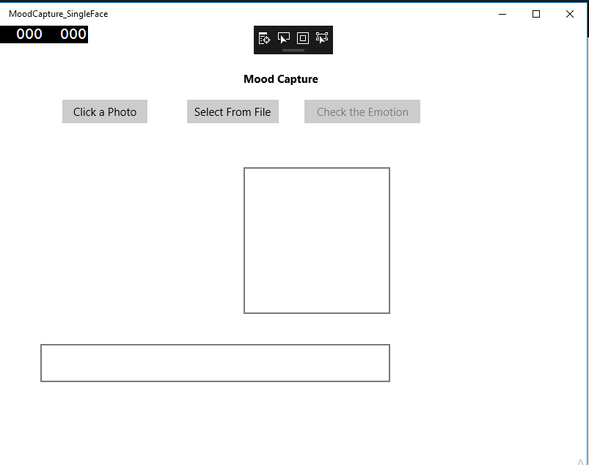

**Clicking a Photo Dynamically by Setting Face in the Rectangle :**

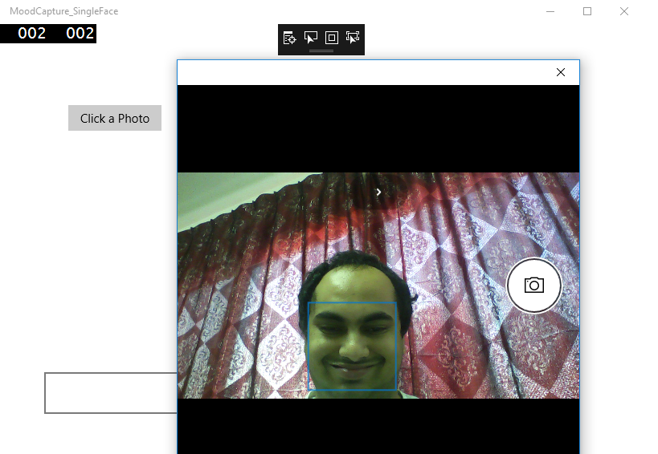

**Cropping if Necessary:**

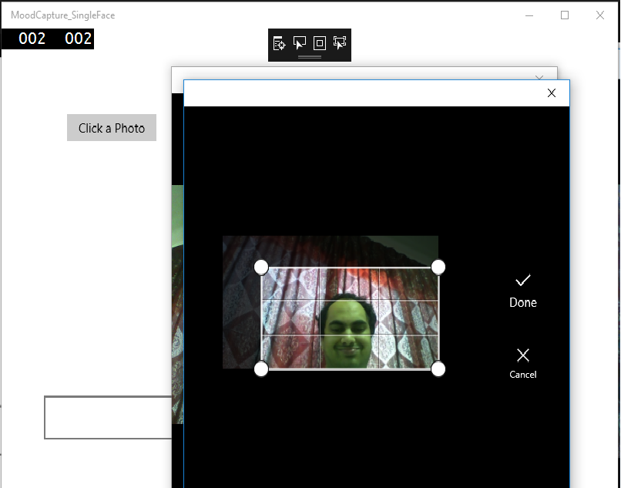

**Cropped Image Appears in an Image Box:**

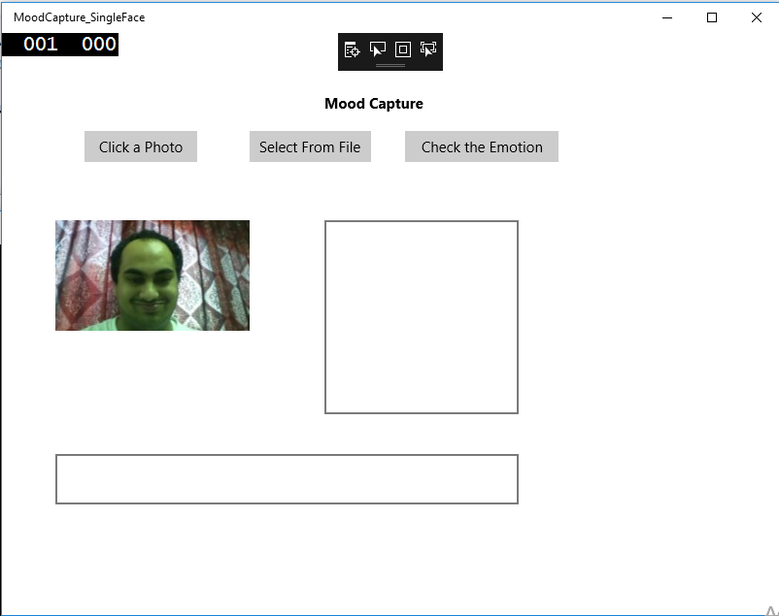

**Checking out the Emotion Returned:**

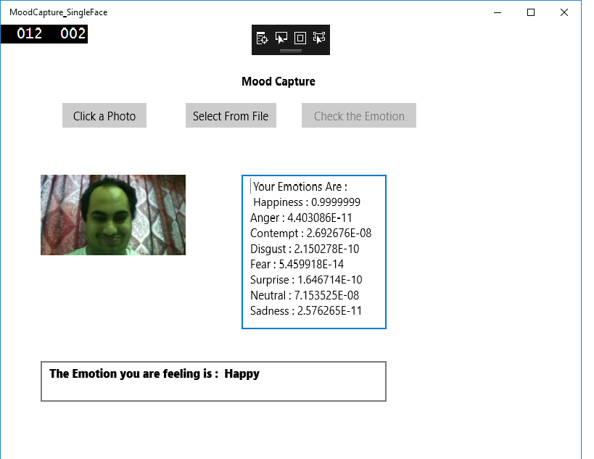

**Selecting the Image from a Location:**

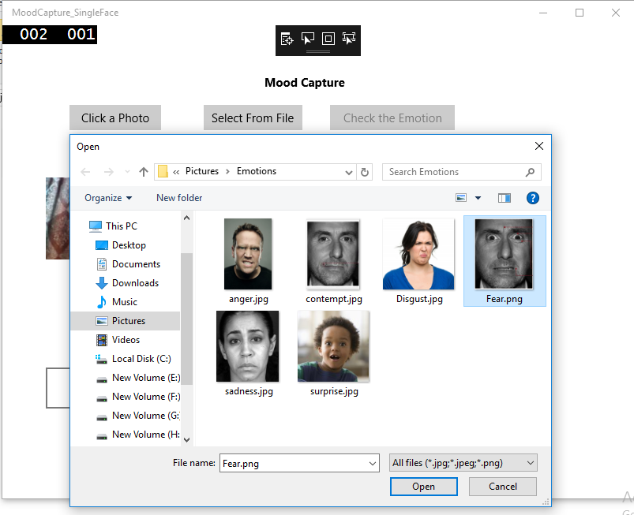

**Selected Image Appears in an Image Box:**

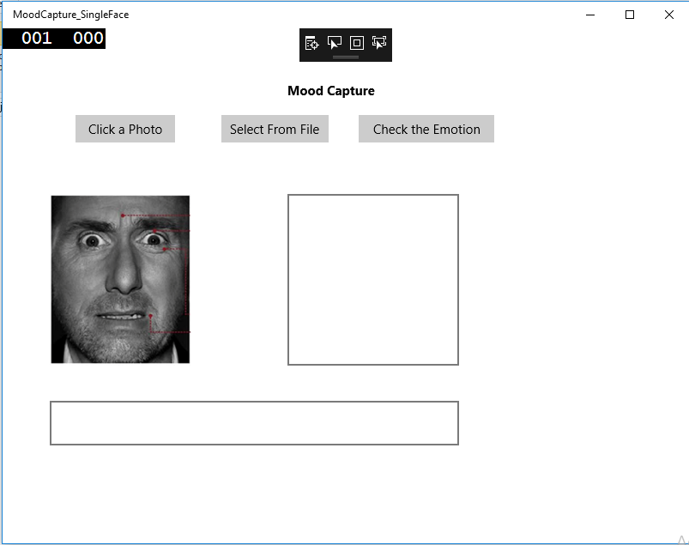

**Emotion Returned By the API:**

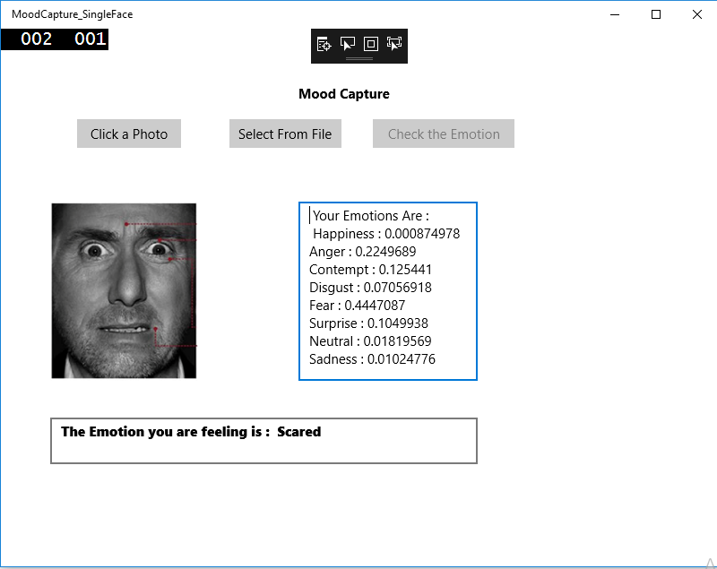

Testing: Exception Screenshots

**Invalid Image Content:**

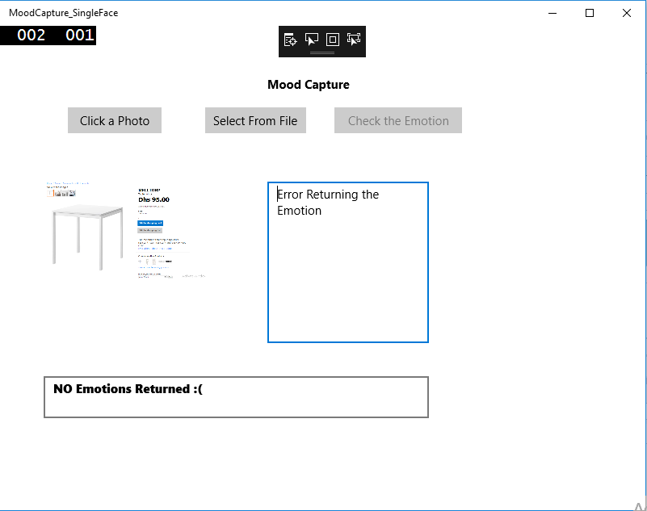

**Unable to connect to the API:**

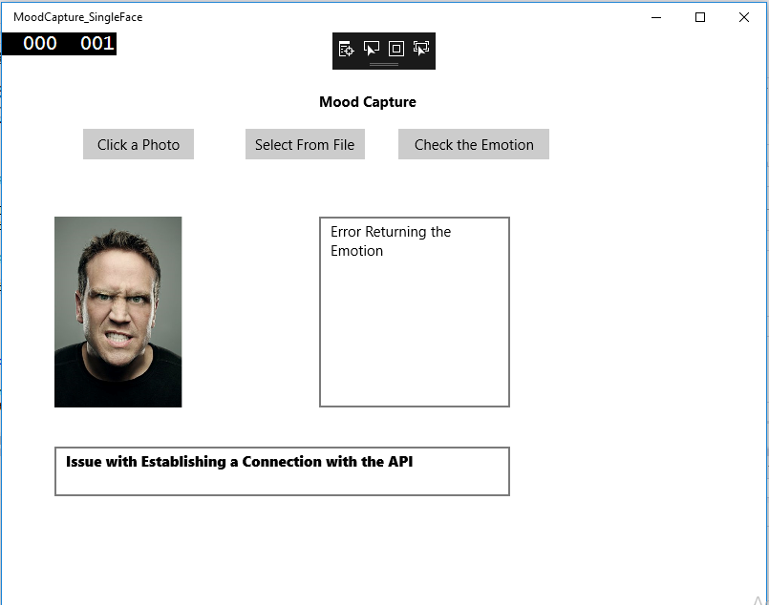

**Allowed File Types:**

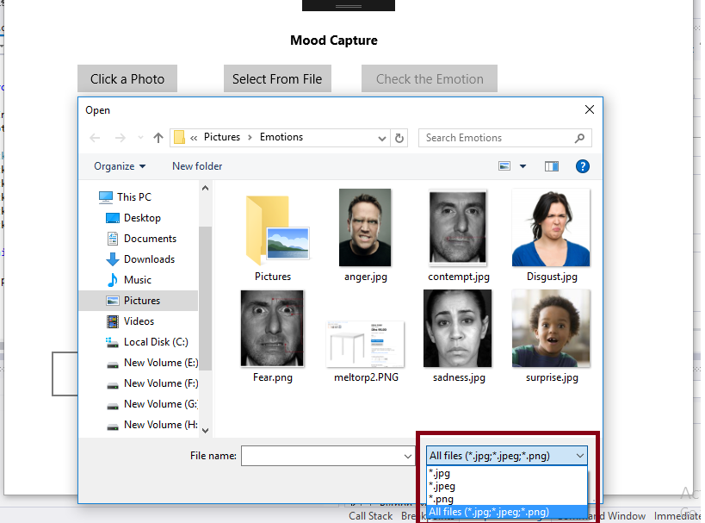

Limitations & Drawbacks

As it is a Universal Windows Platform based Application, a few limitations persist:

* + Users will need to have Windows 10 based Devices or they will need the UWP Bridge
  + The application will need Internet Connectivity.

Future Enhancements

* Will add Speech Recognition and Visual Learning for Holo Lens
* Will add the ability be able to tell if the face is of a celebrity or any pre-configured face

Conclusion

**To conclude, let me give you an overview of the functionalities provided by my Project:**

* To facilitate emotion recognition for any person requiring that
* To be able to run the same application on multiple devices belonging to the UWP Device Family.

Bibliography

* YouTube Tutorials
* https://msdn.microsoft.com
* http://www.google.com/
* http://tutorialspoint.com/